# **Assignment 1 (MSIS2503-40134,40153,40170)**

Q1) Create table named “Student” with the following columns:

* + **Student_ID, First_Name, Last_Name, Birth_Date, Street_Name, city, ZipCode.**
  + **Student_ID is the Primary Key**
* **Screenshot of MYSQL query as shown below for Q1):**

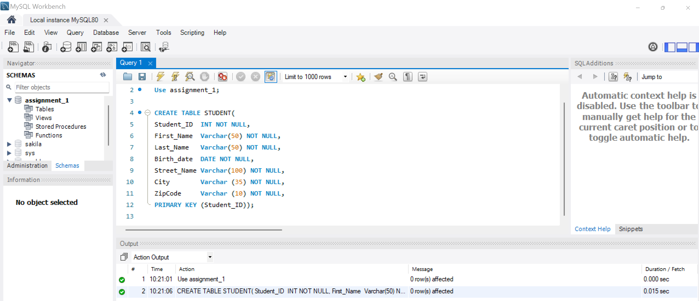

* **Results for Q1:**

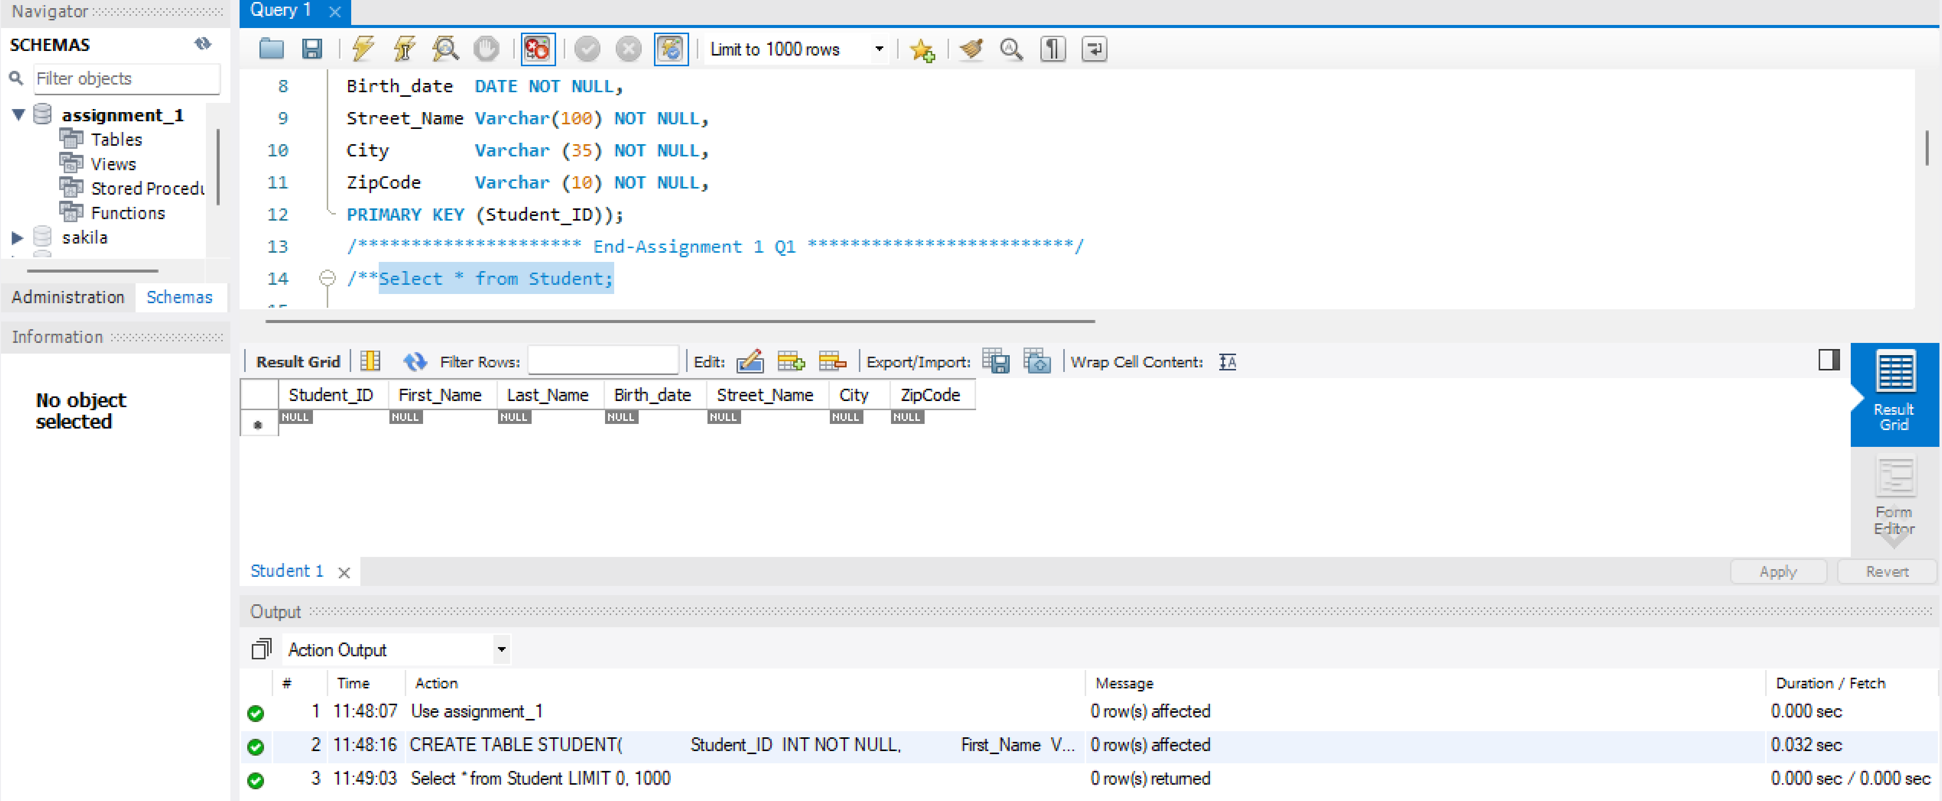

Q2) Alter table to add new column called “Program Varchar(30)” to Student Table:

* **Screenshot of MYSQL query as shown below for Q2):**



* **Results for Q2:**

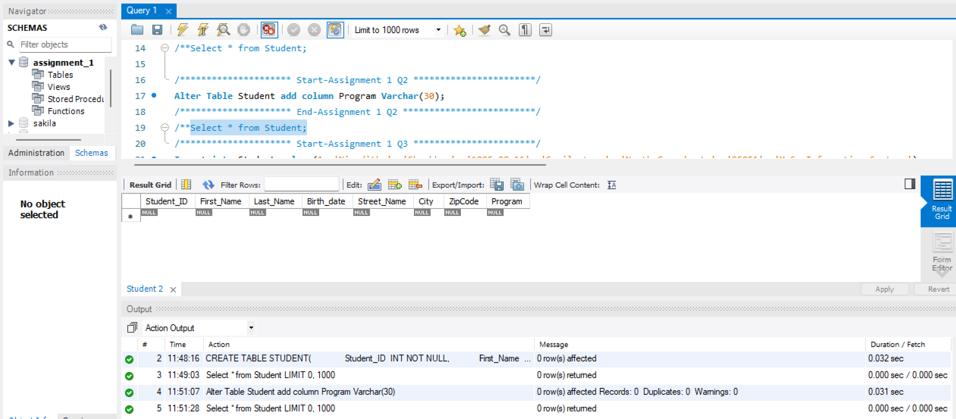

Q3) Insert five records in Student Table with Student_ID 1,2,3,4 and 5:

* **Screenshot of MYSQL query as shown below for Q3):**

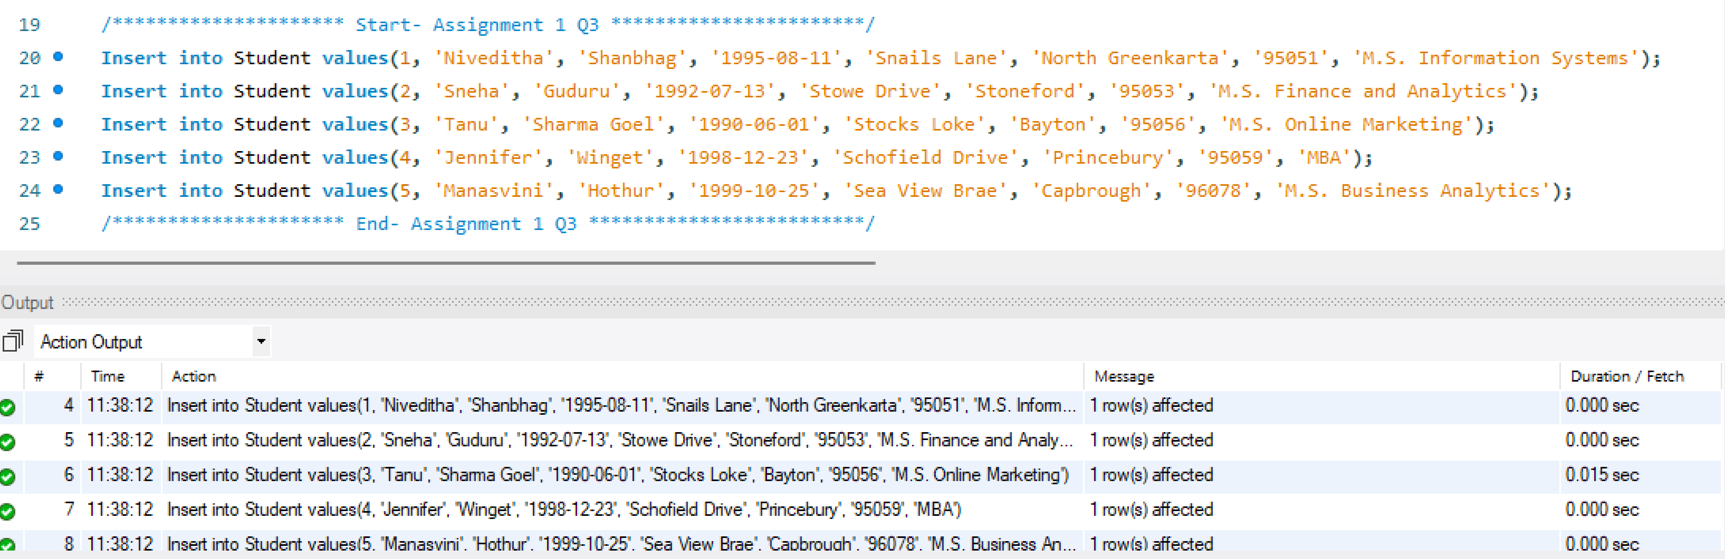

* **Results for Q3:**

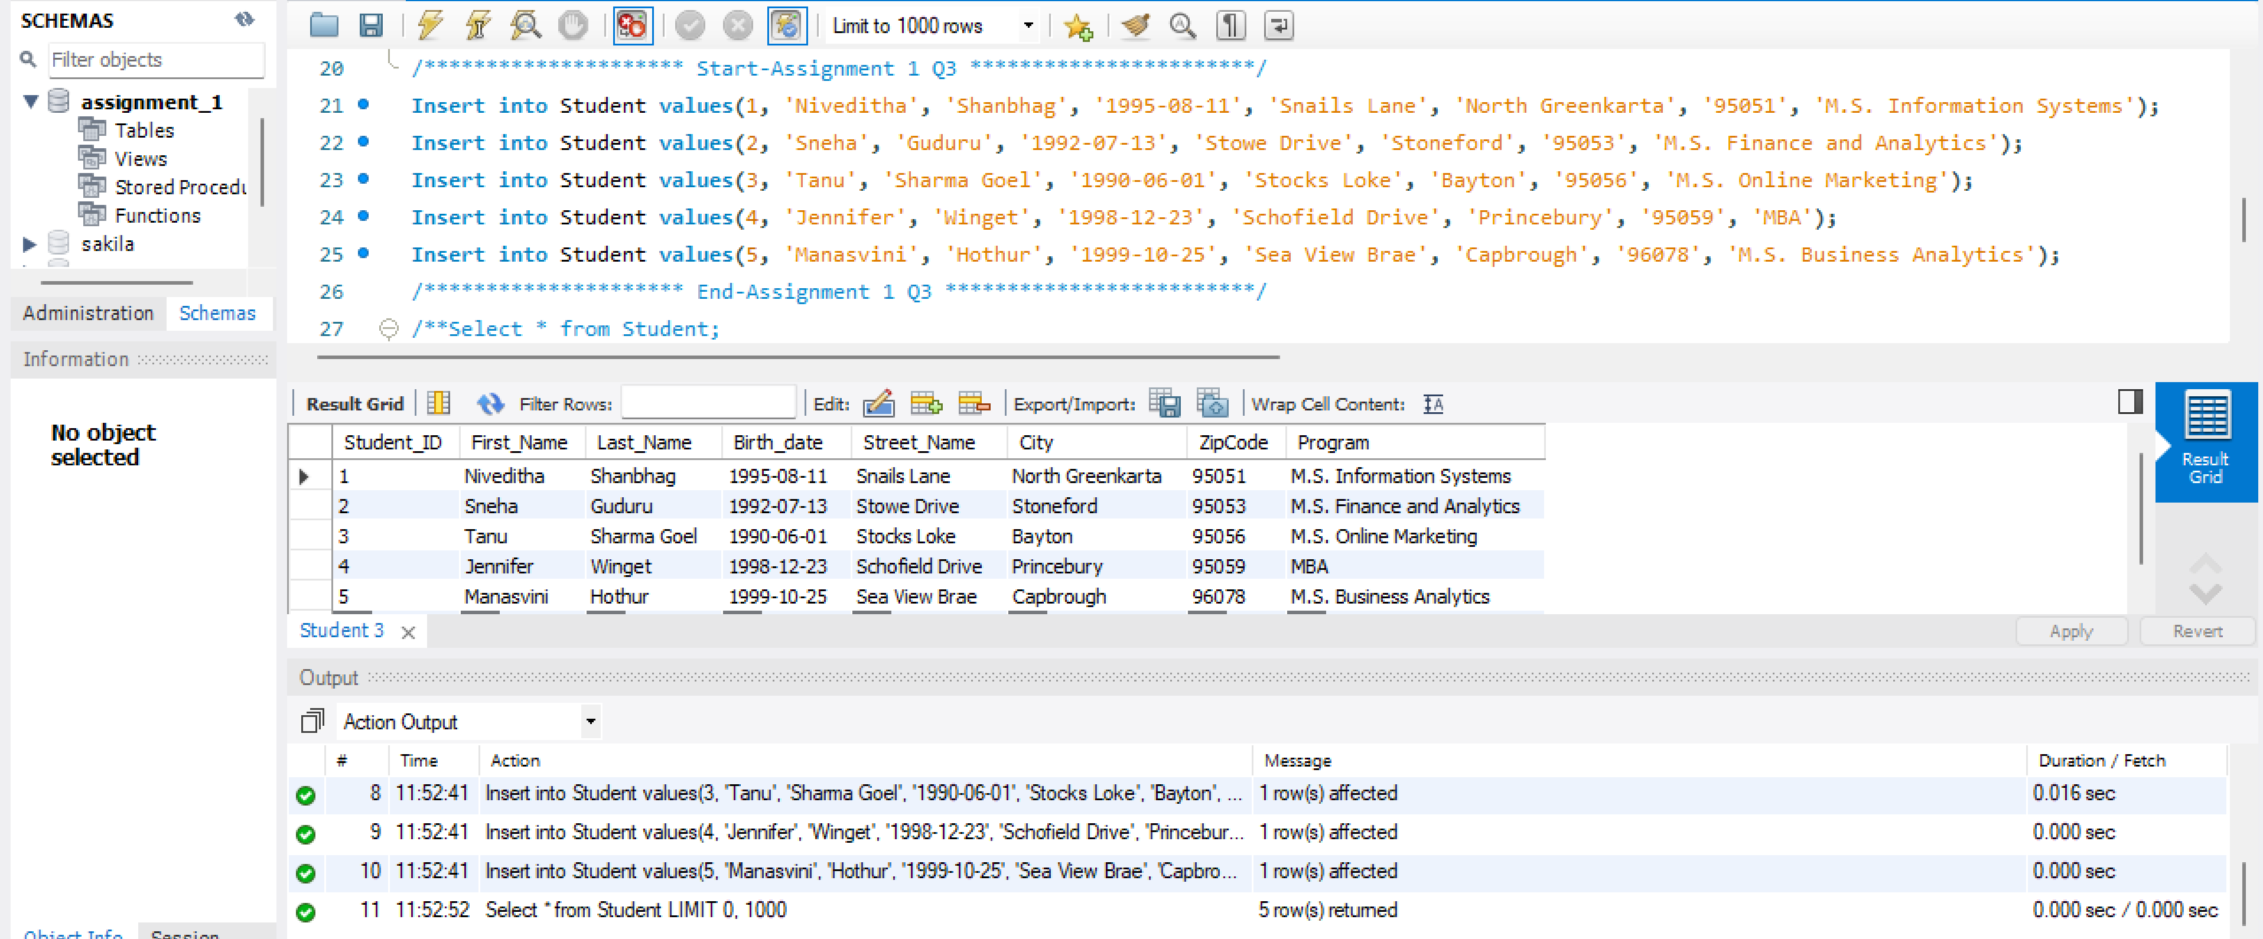

Q4) Update the student`s street_name, city and zipcode for a specific Student_ID.

* **Screenshot of MYSQL query as shown below for Q4):**

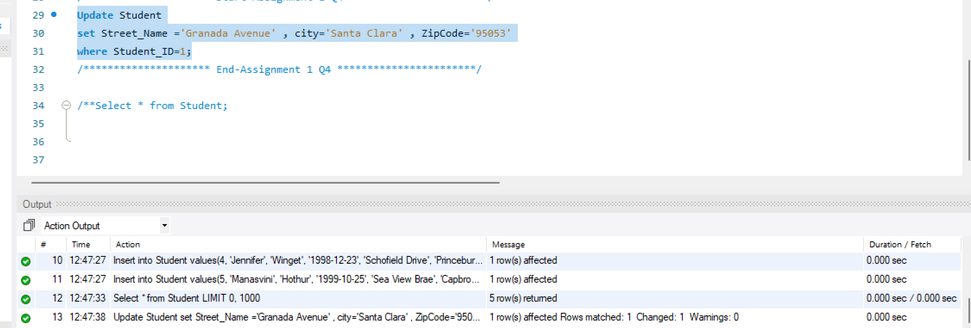

* **Results for Q4:**

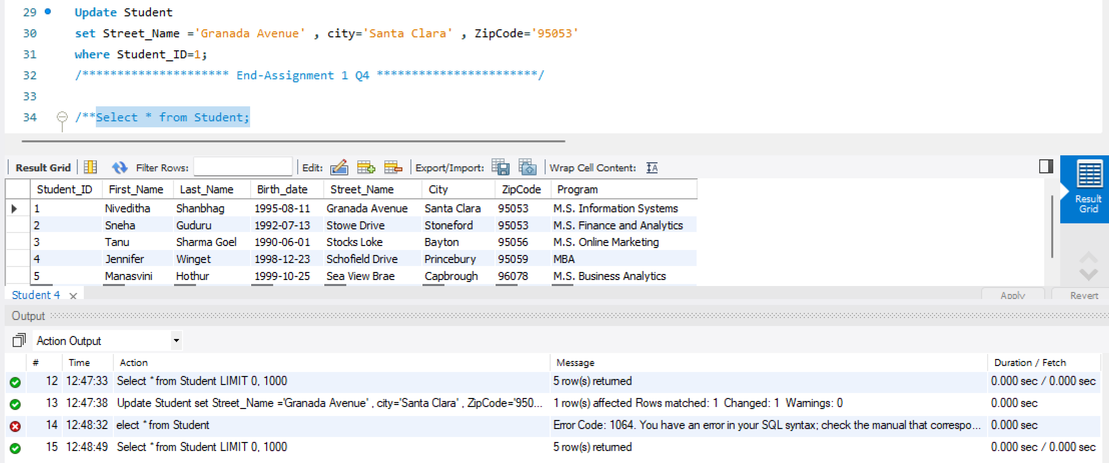

Q5) Delete student record for a specific Student_ID

* **Screenshot of MYSQL query as shown below for Q5):**

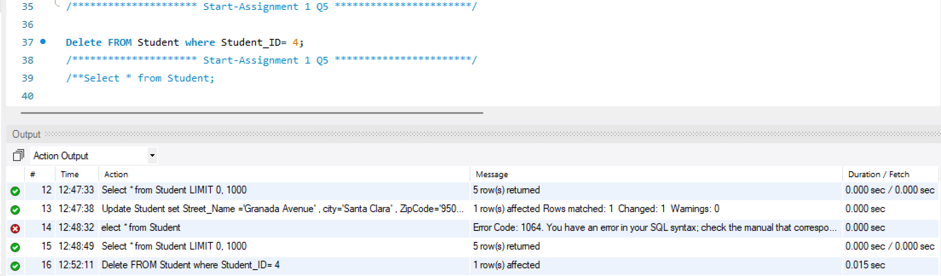

* **Results for Q5:**

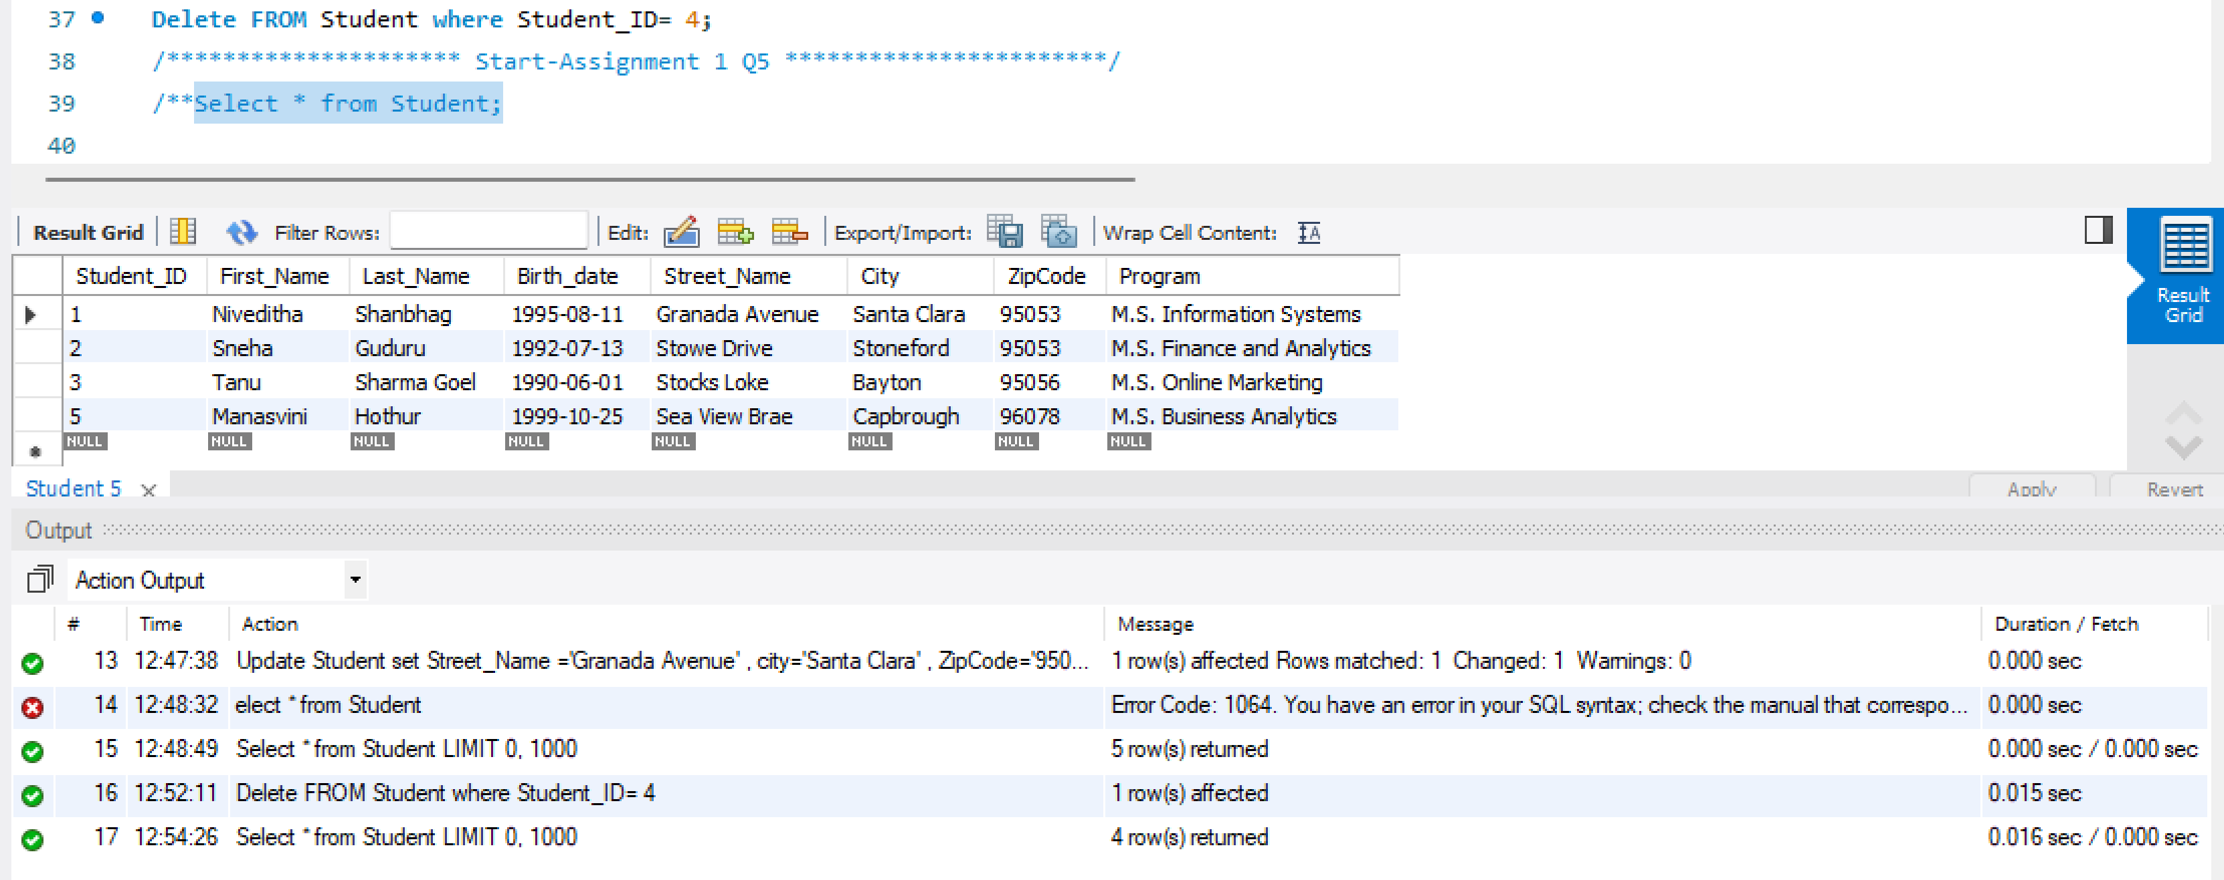

Q6) Add another table named “Courses” with following columns with reference to “Student” table above add Student_ID as foreign key

**Columns for courses Table: Course_ID , Student_ID, Course_Name , Units**

**Course_ID is the Primary Key.**

* **Screenshot of MYSQL query as shown below for Q6):**

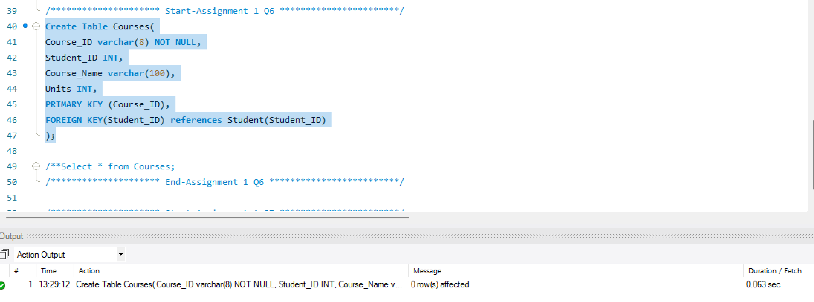

* **Results for Q6:**

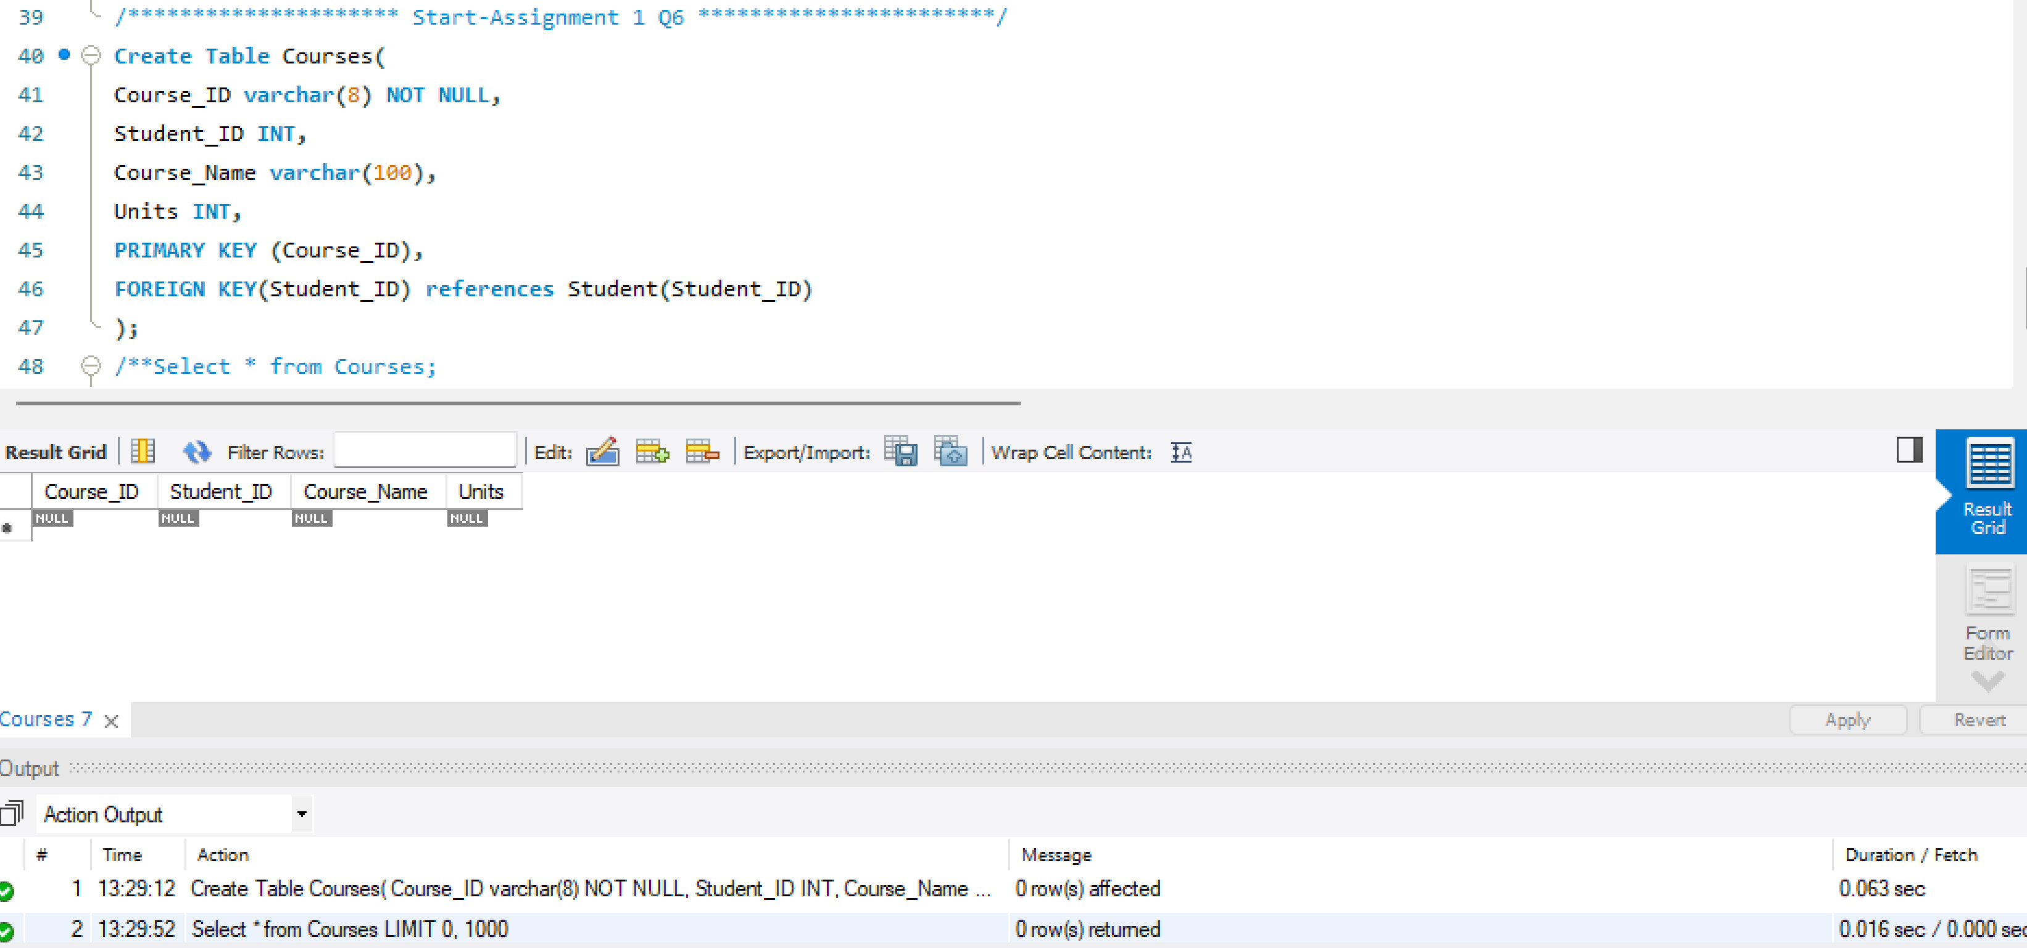

Q7) Insert any 4 records in Courses table that references student_id in Student table.

* **Screenshot of MYSQL query as shown below for Q7):**

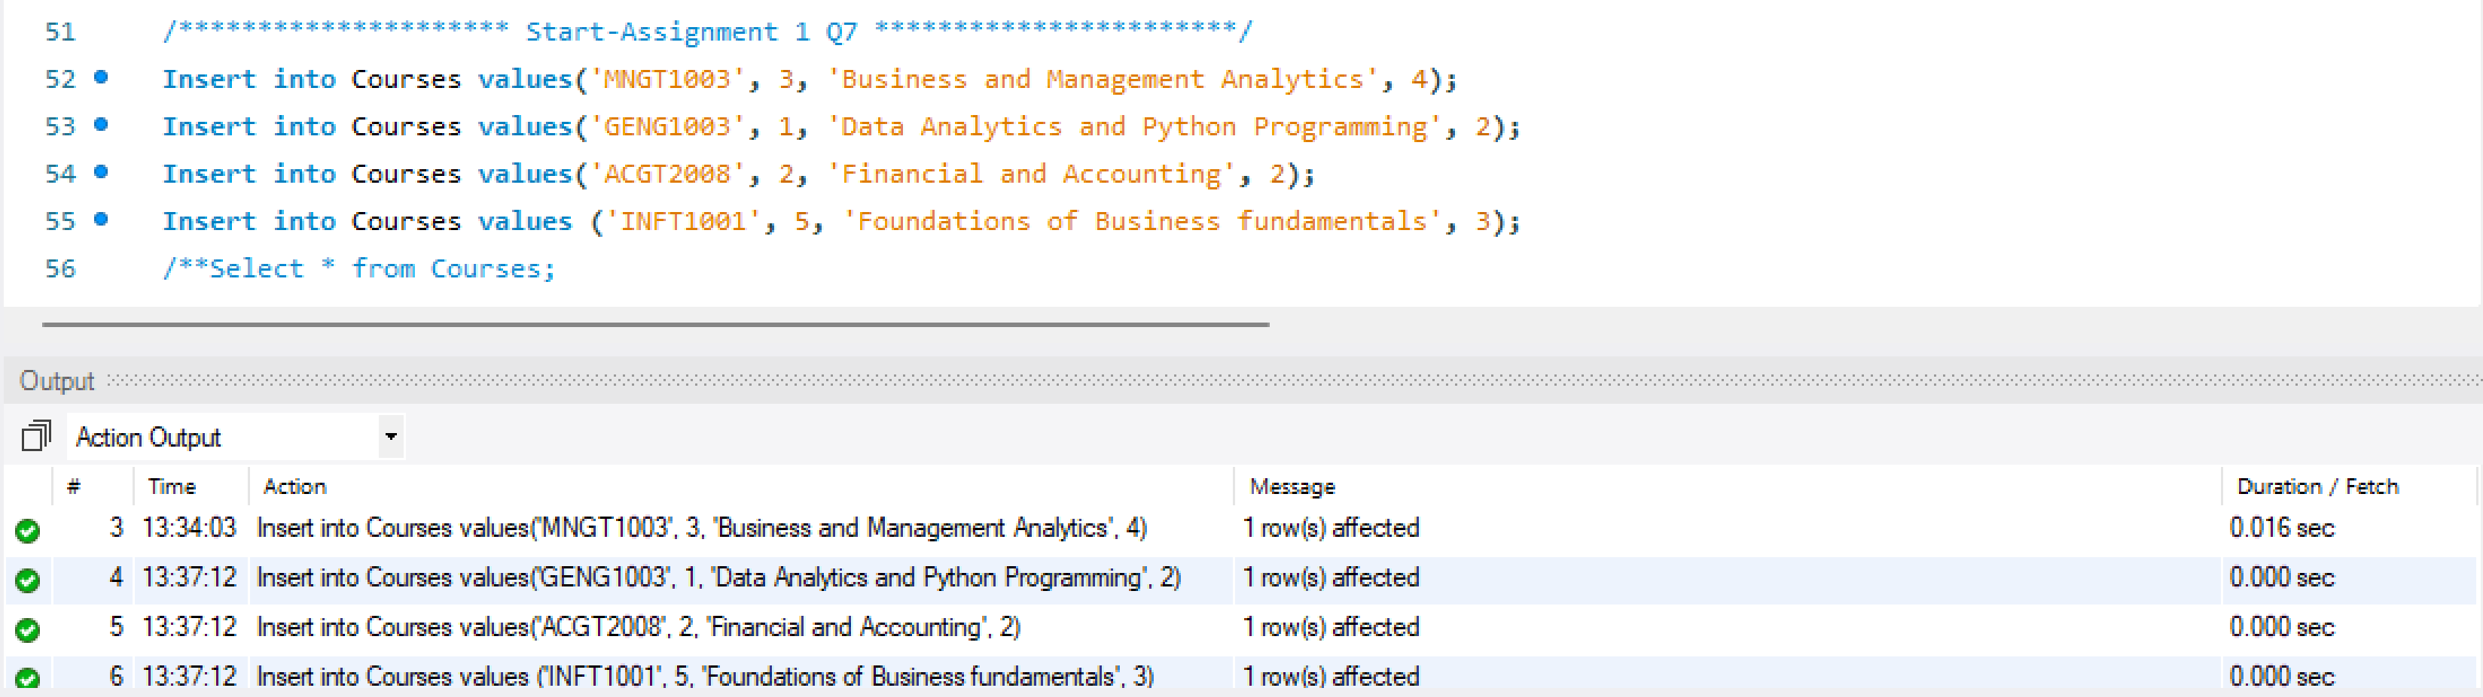

* **Results for Q7:**

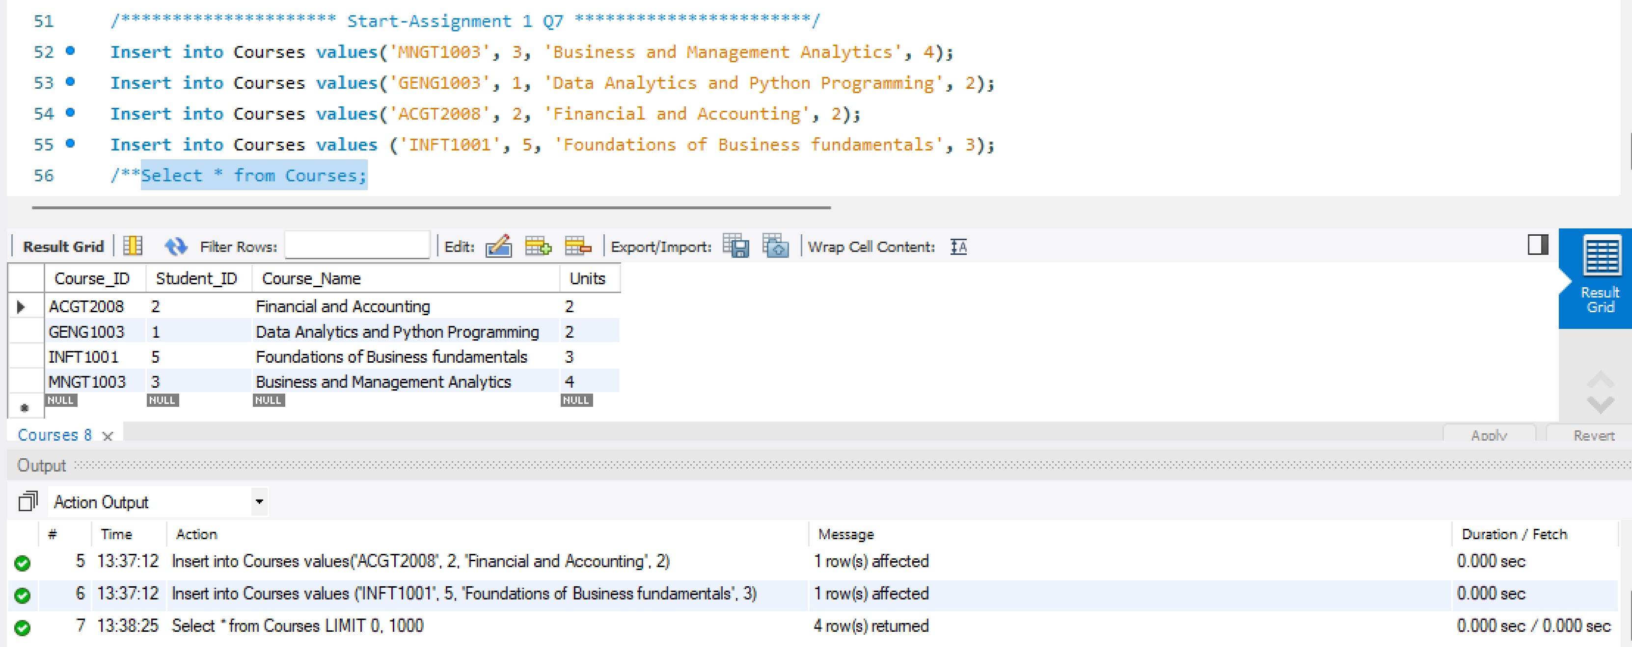

Q8) Insert record into Courses table where the result gives referential Integrity Constraint error for insertion.

* **Screenshot of MYSQL query as shown below for Q8):**

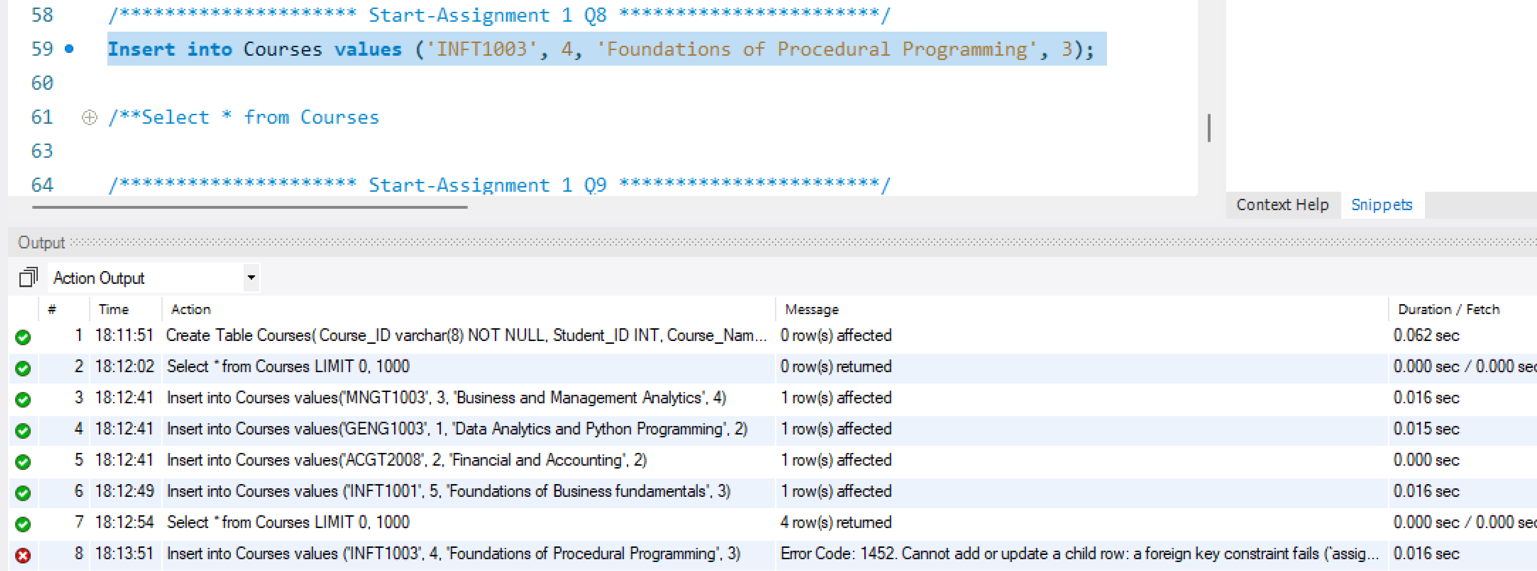

* **Results for Q8:**

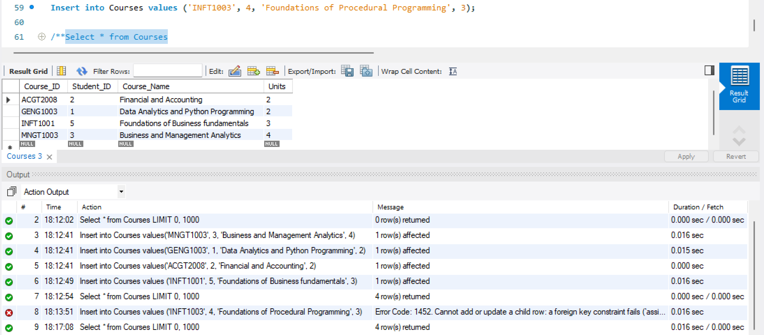

Q9) Delete record from Student table where the result gives referential Integrity Constraint error for deletion.

* **Screenshot of MYSQL query as shown below for Q9):**

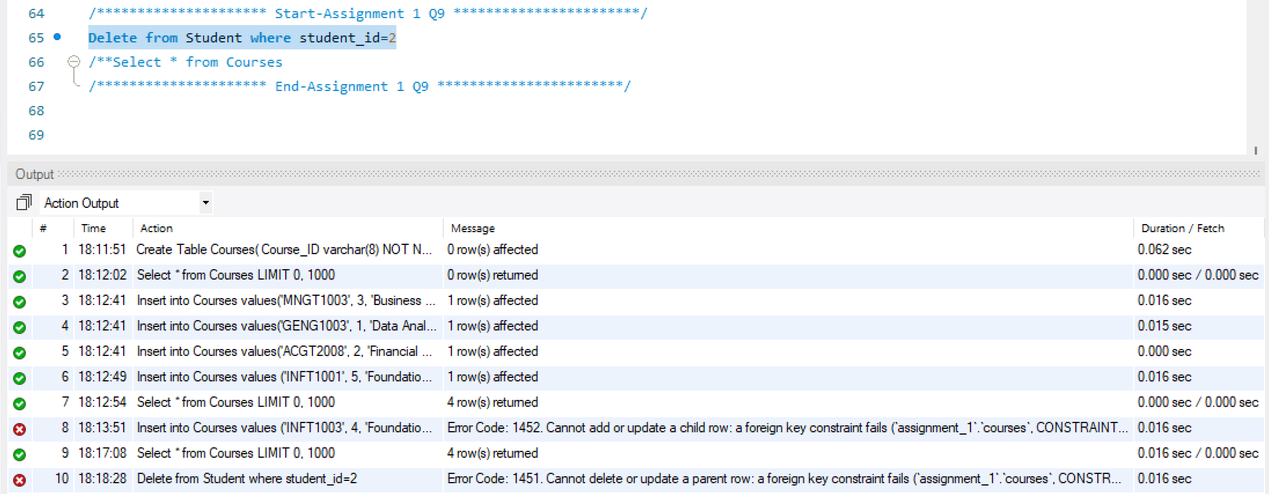

* **Results for Q9:**

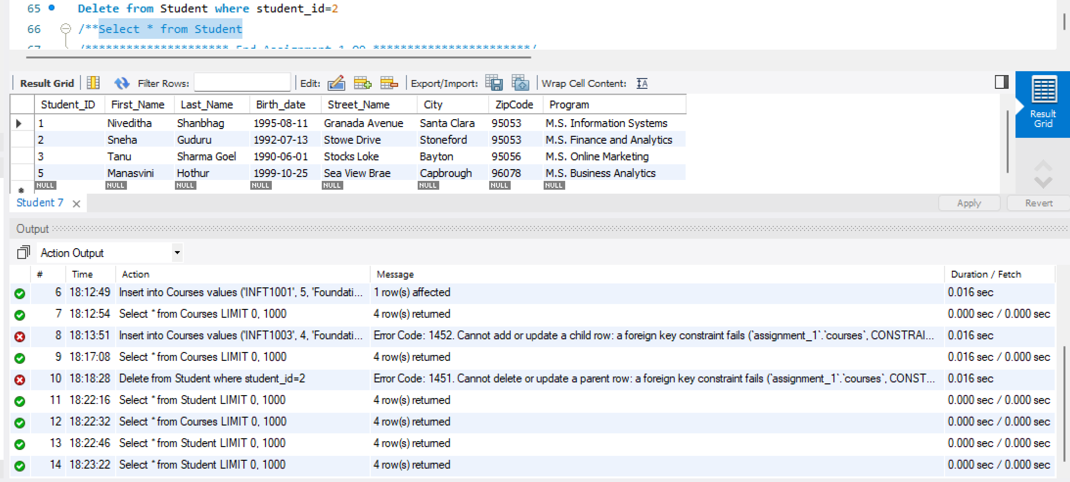

Q10) Resolve the above Referential Integrity Constraint error for deletion (from question 9).

* **Screenshot of MYSQL query as shown below for Q10):**

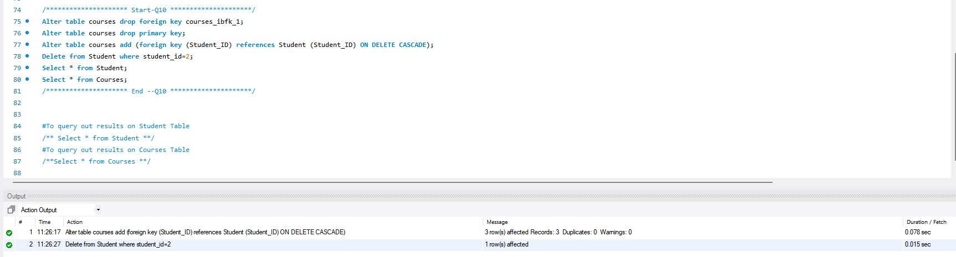

* **Results for Q10:**

